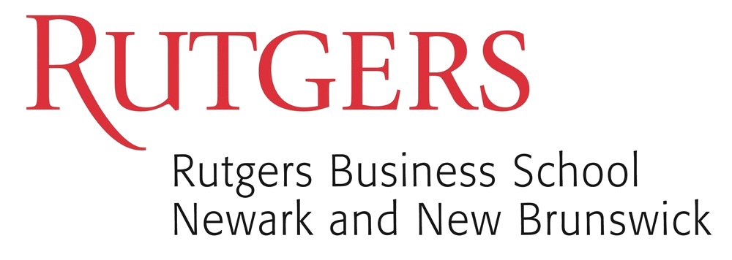

**43rd World Continuous Auditing**

**& Reporting Symposium**

**November 2 & 3, 2018**

**“Disruptive Innovation in Accounting”**

RADAR

Initiative



Platinum Sponsors



Gold Sponsors

  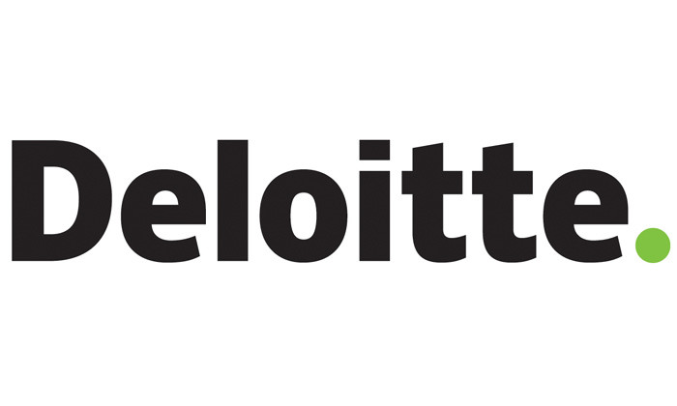 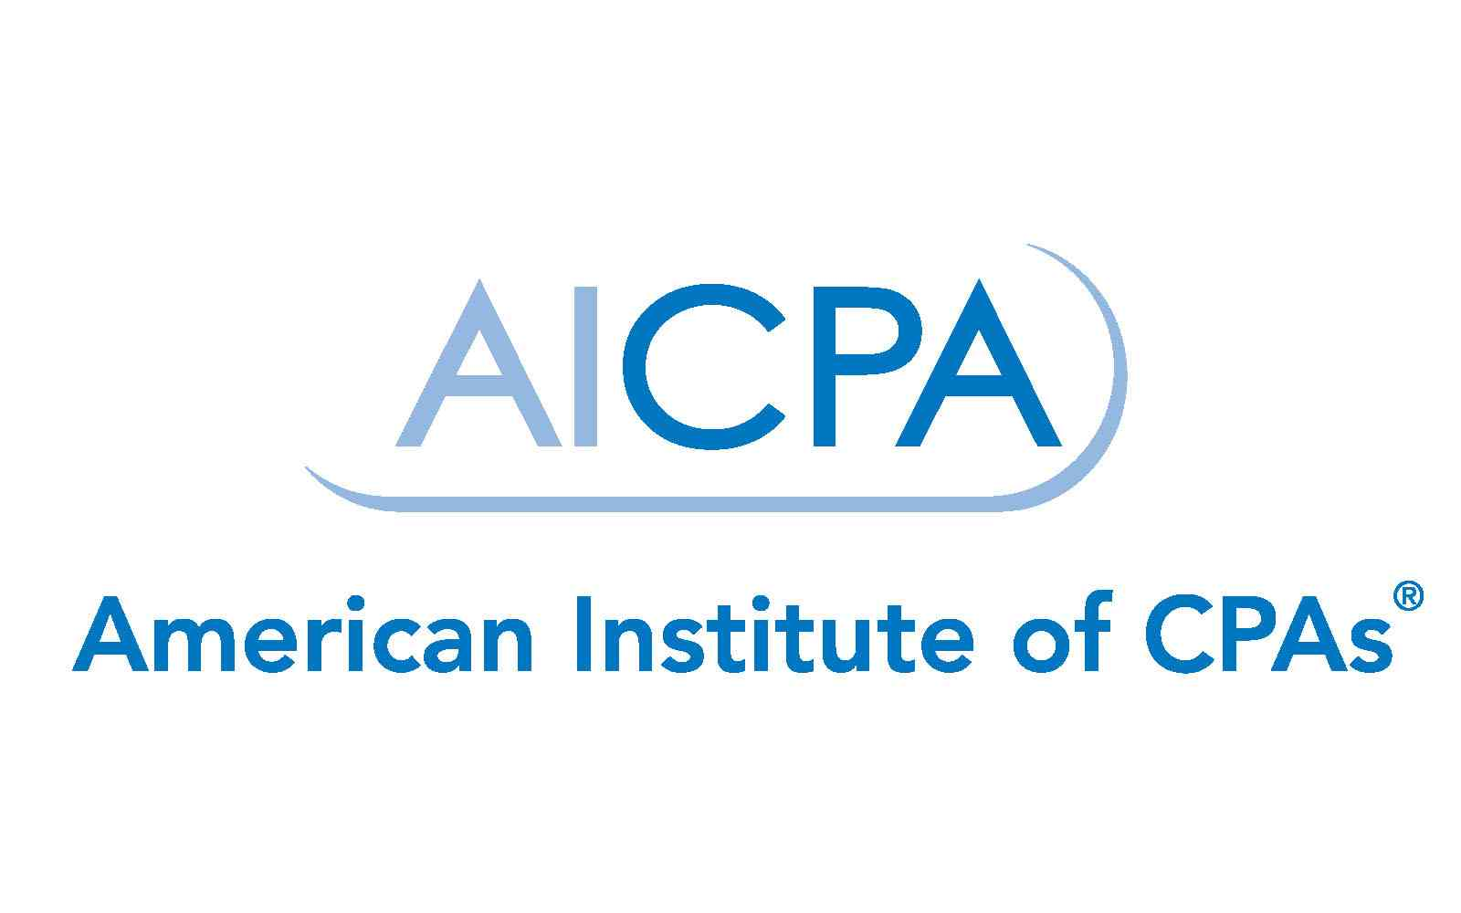



In association with

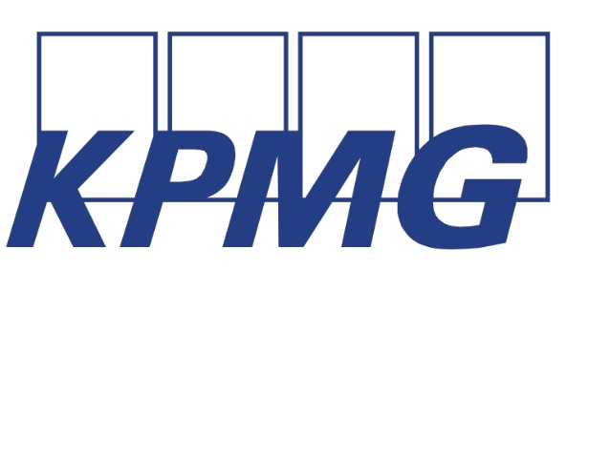  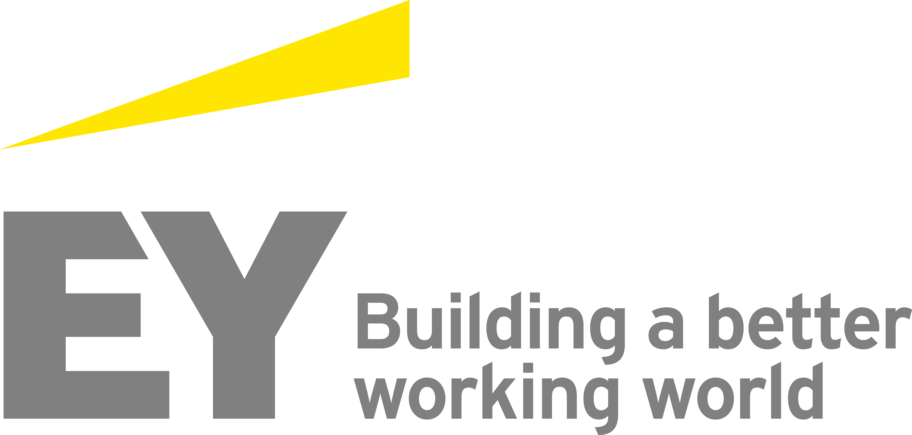

Hosted by: Rutgers Accounting Research Center (RARC)

Continuous Auditing & Reporting Laboratory (CAR Lab)

1 Washington Park, Room 220

Newark, NJ 07102

[www.raw.rutgers.edu/43wcars.html](http://www.raw.rutgers.edu/43wcars.html)

**Location:**

Rutgers Business School, 1 Washington Park, Room 220

Newark, NJ 07102

<http://raw.rutgers.edu/43wcars.html>

**43 WCARS Executive Committee:**

***Dr. Miklos A. Vasarhelyi***, Symposium Co-Chair, Director - Rutgers Accounting Research Center (RARC)

& Continuous Auditing & Reporting Lab (CAR Lab), KPMG Distinguished Professor of

Accounting Information Systems

***Dr. Michael G. Alles*,** Symposium Co-Chair, Professor of Accounting Information Systems,

Editor, International Journal of Disclosure and Governance

***Dr. Alexander J. Sannella***, Director - MBA in Professional Accounting &

Director of the Teaching Excellence Center

***Barbara Jensen,*** Program Administrator**,** Rutgers Accounting Research Center & Continuous

Auditing & Reporting Lab

14 CPE credits in auditing will be awarded for this program. Rutgers Business School is registered with the

National Association of State Boards of Accountancy (NASBA) as a sponsor of continuing professional

education on the National Registry of CPE Sponsors. State boards of accountancy have final authority on the

acceptance of individual courses for CPE credit. Complaints regarding registered sponsors may be

submitted to the National Registry of CPE Sponsors through its website: [*www.learningmarket.org.*](http://www.learningmarket.org/)

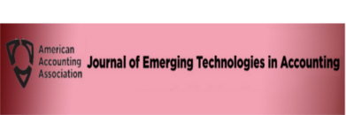



*In association with:*

***43rd WCARS***

**Friday, November 2, 2018**

**8:00 AM REGISTRATION & CONTINENTAL BREAKFAST (2nd Floor Student Lounge)**

**8:30 AM Introduction & Welcome:**

***Dr. Yaw Mensah* –** Executive Vice Dean, Rutgers Business School, RBS –

Newark & New Brunswick

***Dr. Michael G. Alles* -** Symposium Co-Chair, Professor of Accounting Information Systems, RBS

***Dr. Miklos A. Vasarhelyi* -** Symposium Co-Chair, Director ,

Rutgers Accounting Research Center (RARC) /Continuous

Auditing & Reporting Lab (CAR Lab), KPMG Distinguished

Professor of Accounting Information Systems, RBS

**8:45 AM Session I:“Tools for the Digital Audit’’**

***Kevin Simon****,* Product Lead, Analytics, CaseWare

**9:30 AM Session II: “A Time of Epochal Change in Audit & Accounting :**

**Are You Ready?”**

***Dr. JT Kostman***, Managing Director of Applied Artificial Intelligence,

Grant Thornton LLP

**10:15 AM BREAK & NETWORKING (2nd Floor Student Lounge)**

**10:35 AM Session III: “What Auditors Need to Know about Blockchain and Other Emerging Technologies: A Regulator’s Perspective”**

***Kathleen Hamm****,* J.D., LL.M., Board Member, Public Company Accounting Oversight Board

**11:25 AM Session IV: “ Analyzing, Monitoring, Automating and Learning**

**with ACL Robotics*”***

***Shahed Khalili***, Managing Director of Strategy & Performance

Governance, ACL Services

**12:00 PM LUNCHEON at the NEWARK MUSEUM, Engelhard Court, 1st Floor**

**49 Washington St, Newark, NJ 07102**

**1:15 PM Session V: “Update on the Rutgers AICPA Data Analytics Research Initiative” (RADAR)**

***Brian Miller*,** CPA, Chairman of RADAR Advisory Board & National Assurance Partner, Transformation and Innovation, BDO

**2:05 PM Session VI: “ Trends in Machine Learning and AI”**

***Vikram Panjwani,*** Partner, Risk Assurance, PricewaterhouseCoopers LLP

**2:35 PM Session VII: “ “Robotic Process Automation: Leveraging for Audit”**

***Carrie Gilstrap*,** Program Manager – IT, Internal Audit , HP Inc.

***Meredith Trabinska*,** Senior Program Manager , Intelligent Automation,

HP Inc.

**3:05 PM BREAK & NETWORKING (2nd Floor Student Lounge)**

**3:20 PM Session VIII: “Introduction to Blockchain”**

***Dr. Michael Alles,*** Professor of Accounting Information Systems, RBS

**3:30 PM Session IX: “Auditing Blockchain”**

***Dr. Gerard Brennan*,** CFE, Audit Technologies Director - Libra

**4:00 PM Session X: “The Digital Pink Slip-A Blockchain Use Case for Automobile Registration”**

***Dr. Cory Campbell*,** Professor of Accounting**,** Indiana State University

***Dr. Dijo Alexander*,** Head of Technology – Learning Management, SAP

Faculty at University of Wisconsin

**4:45 PM Session Xl: “Open Information Enterprise Transactions: Business Intelligence and Wash & Spoof Transactions in Blockchain & Social Commerce”**

***Dr. Daniel O’Leary***, Professor, University of Southern California

**5:15 PM ADJOURNMENT**

**6:00 PM DINNER at the Spanish Pavillion, 31 Harrison Ave, Harrison, NJ 07029**

**SPONSORED BY:**



***43rd WCARS***

**Saturday, November 3, 2018**

**8:00 AM CONTINENTAL BREAKFAST (2nd Floor Student Lounge)**

**8:30 AM Session I: “Utilizing Social Media: Text Mining Analysis for *Government Financial Data”***

***Zamil Alzamil,*** PhD Student, RBS

***Dr. Deniz Appelbaum****,* Assistant Professor**,** Montclair State University

***Dr. Rob Nehmer***, Professor, Oakland University

**8:55 AM Session II: “Utilizing Blockchain and Smart Contracts to Enable Audit 4.0: A Case of Accounting Audit of Air Pollution Control in China”**

***Dr. Jun Dai,*** South Western University of Finance and Economics, China

**9:20 AM Session III: “Contract Analytics in Auditing”**

***Zhaokai Yan*,** PhD student, RBS

**9:45 AM Session IV: “Big Data Analytics as a Strategic Capability in Industrial Firms”**

***Dr. Dijo Alexander****,* Head of Technology- Learning Management – SAP

Faculty at University of Wisconsin

**10:15 AM BREAK & NETWORKING (2nd floor lounge)**

**10:30 AM Session V: “Framing Audit Analytics within the Auditing Standards”**

***Edward S. Wilkins****,* Insurance Leader, Audit and Assurance, Deloitte

& Touche LLP

**11:00 AMSession VI: “The Role of Audit Documentation in a Continuous Auditing Environment”**

***Eric E. Cohen,*** Cohen Computer Consulting

**11:25 AM Session VII: “Text Mining & Textual Analysis in Accounting”**

***Dr. Rajendra Srivastava,*** Professor Emeritus, University of Kansas

**11:50 AM Session VIII: “CAR Lab Update on Brazilian Research Projects”**

***Dr. Mauricio Codesso***, Continuous Auditing & Reporting Lab Researcher

**12:15 PM  *LUNCH – (2nd Floor Student Lounge)***

**1:05 PM Session IX: “Current CAR Lab Research: Rutgers PhD Students”**

**“Intelligent Process Automation in Audit*”***

***Chanyuan (Abigail) Zhang***

**“Redoing Ratio Analysis with Clustering Techniques*”***

***Kexing Ding & Xuan Peng***

**“If You Can’t Measure It, You Can’t Manage It: Cybersecurity**

**Risk Measurement Through Textual Imagification”**

***Arion Cheong***

**“Enhancing Substantive Analytical Procedures with Third Party Generated Information from Social Media”**

***Andrea Rozario***

**“Does the Internal Control Risk Factor Disclosure Complement SOX**

**404 Disclosure of Aerial Weaknesses in Internal Control?”**

***Yue Liu***

**“Automating the Audit Procedures*”***

***Nuriddin Tojiboyev***

**“Critical Audit Matter Modifications Affect Investors: Evidence from Taiwan*”***

***Sheng- Feng (Philip) Hsieh***

***“*The Future of Accounting Education*”***

***Abdulrahman Alrefai***

**“Applications of Blockchain to Government Open Checkbooks”**

***Eid Alotaibi***

**3:15 PM CLOSING COMMENTS & ADJOURNMENT**